C/C++ STUDENT 'CLASS' LAB REPORT

1) Enter your name, student ID, platform (Mac or PC) and date
Name and Student ID: Jay Gupta, Student ID: 0961979
Class: CIS054 C/C++ Programming
Platform (Mac or PC): PC
Date: 5/4/2020

DESCRIPTION:
Modify the Student 'class' files as follows:
1) Add a Major field to the Student class definition. Update the student.h and student.cpp files to include the additional field. Be sure to include a get and set method for the Major field. ✔
2) Add several majors such as CIS, Math, English, etc. to the students in the array of students located in the main program. ✔
3) When displaying the list of student ID numbers and student names, also display their major. For C++ use the setw( ) function to set the widths of each column so that the columns line up on the screen when displayed. For the C-language, set the parameters for %s in the format string. ✔
4) Change some of the ID numbers and GPAs to illegal values. Have the program detect and display an error message when the illegal values are present. ✔

EXTRA CREDIT: 3 points – must be submitted at the same time as the original lab report
Display a header at the top of the table similar to: ✔
ID # NAME MAJOR
============================================

LAB REPORT:
2) Determine the Inputs, Processing and Outputs before creating the program
INPUTS | PROCESSING | OUTPUTS
- Not exactly “user-inputs”, but it’s the values entered in the CIS054 array. | - Take in inputs from CIS054 array, setting fields  - Create the header  - For each student in CIS054, show id, name, and major  - Calculate average GPA by getting total GPA, dividing by number of students. Display this value  - Display any error values if need be, for invalid GPA or ID | - Table showing id, name, and major  - Average GPA  - Error Message(s)

3) Fill in the EXPECTED & ACTUAL RESULTS
TEST DATA VALUES  Provide different examples including an illegal Student ID | EXPECTED RESULT  Computed values before the program is run |  | ACTUAL RESULT  Fill in the output displayed  by the program
1. Student ("Joe Williams", 42923, 3.4, "CIS")  2. Student ("Fred MacIntosh", 43252, 2.8, "Ethnic Studies")  3. Student ("777 Dan McElroy", 77777, 4.0, "CIS")  4. Student ("Jose De La Cruz", -990, 3.0, "Chemistry")  5. Student ("Thinh Nguyen", 73657, 5.0, "Geology") |  | 1. 42923 Joe Williams CIS  2. 43252 Fred MacIntosh Ethnic Studies  3. 77777 --Bad name entered CIS  4. 0 Jose De La Cruz Chemistry  Illegal ID value for Jose De La Cruz!  5. Illegal GPA value for Thinh Nguyen! | 1. 42923 Joe Williams CIS  2. 43252 Fred MacIntosh Ethnic Studies  3. 77777 --Bad name entered CIS  4. 0 Jose De La Cruz Chemistry  Illegal ID value for Jose De La Cruz!  5. Illegal GPA value for Thinh Nguyen!
DISCUSSION:
4) Complete the DISCUSSION section. It does not need to be long, but it needs to be complete.
4a) What did you do to develop the program? ("Followed the Directions" is not a complete description)

To develop the program, I first learned about classes and objects from the assigned slides. After that, I followed the instructions (which were very helpful) to create the program. I used the already created functions and data to create the major field, and debugged where I needed to.

4b) What problems did you have and how did you overcome the problems?

I had a problem with setw(). Mainly, I didn’t understand how to make it fit my needs. I researched on Google, however, a particular YouTube video was very helpful. I understood how to use it, and was able to create the project perfectly.

PROGRAM OUTPUT:
5) Show a screen of the program execution that includes an illegal selection for name. The columns of data need to be left justified.
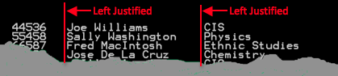
For extra credit, display a header row and a ==== separator line.
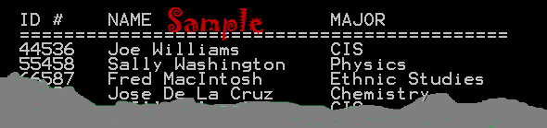
Refer to previous lab assignments for instructions on how to capture a screen or portions of a screen for either the PC or a Mac

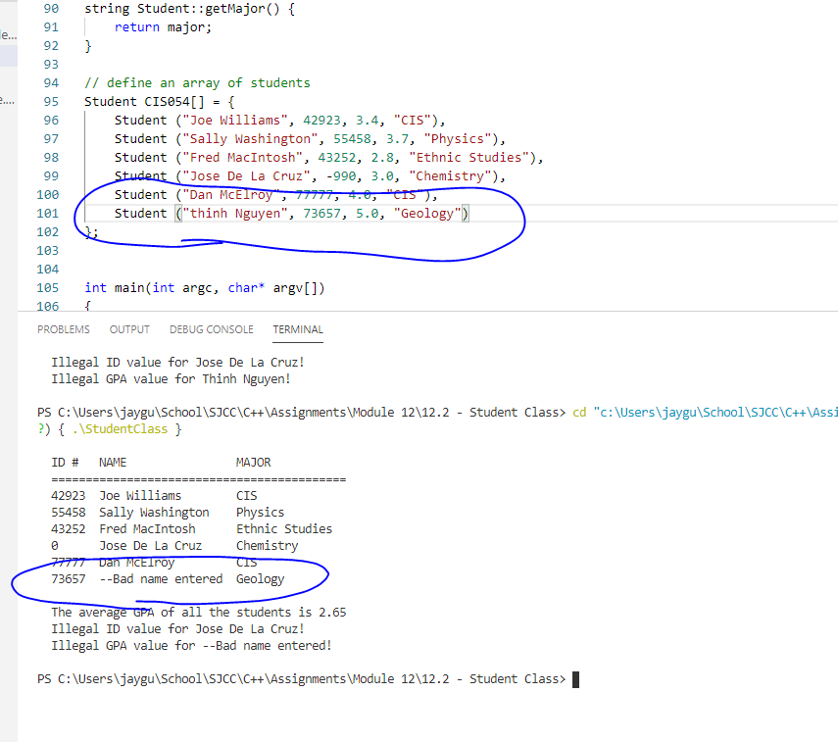

PROGRAM LISTING:
6) Copy and paste the code for the program work. Your program should include a comment block at the top that shows the name of the program, date, version and your name.

/*
* Name: Jay Gupta
* Program: StudentClass.cpp (V1.0)
* Date: 5/4/2020
* Professor McElroy
* CIS054 C/C++ Programming
*/

#include <string>
#include <iostream>
#include <cctype> // used by isalpha (test for a character)
#include <iomanip>
using namespace std;

class Student
{
private:
string name;
int IdNumber;
double gpa;
string major;
public:
// constructors
Student(); // default constructor
Student(string n, int id, double g, string major);

//mutators and accessors
void setName(string n);
string getName();
void setIdNumber(int id);
int getIdNumber();
void setGpa(double g);
double getGpa();
void setMajor(string major);
string getMajor();
};

// default Student constructor
Student::Student()
{
name = ""; // set name to an empty string
IdNumber = 0;
gpa = 0.0;
major = ""; // set major to an empty string
}
// Fully qualified Student constructor
Student::Student(string n, int id, double g, string m)
{
setName(n); // use setName to validate data
setIdNumber(id); // use setIdNumber to validate data
setGpa(g); // use setGpa to validate data
setMajor(m); // use setMajor to validate data
}

//mutators and accessors
void Student::setName(string n)
{
if ( isupper(n[0]) ) // 1st character of name must be A-Z
name = n;
else
name = "--Bad name entered";
}
string Student::getName()
{
return name;
}
void Student::setIdNumber(int id)
{
if ( id>1 && id<100000) // must be from 0 to 100000
IdNumber = id;
else
IdNumber = 0; // indicate an illegal selection
}
int Student::getIdNumber()
{
return IdNumber;
}
void Student::setGpa(double g)
{
if (g>=0.0 && g<=4.0) // gpa must be from 0.0 to 4.0
gpa = g;
else {
gpa = -1; // illegal value
}
}
double Student::getGpa()
{
return gpa;
}
void Student::setMajor(string m) {
if (isupper(m[0])) {
major = m; // want first letter, like name, to be capitalized
} else {
major = "Invalid major.";
}
}
string Student::getMajor() {
return major;
}

// define an array of students
Student CIS054[] = {
Student ("Joe Williams", 42923, 3.4, "CIS"),
Student ("Sally Washington", 55458, 3.7, "Physics"),
Student ("Fred MacIntosh", 43252, 2.8, "Ethnic Studies"),
Student ("Jose De La Cruz", -990, 3.0, "Chemistry"),
Student ("Dan McElroy", 77777, 4.0, "CIS"),
Student ("thinh Nguyen", 73657, 5.0, "Geology")
};

int main(int argc, char* argv[])
{
int NumberOfStudents = sizeof(CIS054)/sizeof(Student);

// header
cout << endl << left << " " << setw(7) << "ID #" << setw(20) << "NAME" << "MAJOR" << endl;
cout << " " << "===========================================" << endl;

// Display the header line
// List all the students in the course
for (int i=0; i<NumberOfStudents; i++)
cout << " " << left << setw(7) << CIS054[i].getIdNumber() << setw(20) << CIS054[i].getName() << CIS054[i].getMajor() << endl;
cout << endl; // blank line after displaying the student names

// compute the average gpa of all the students
double total=0;
for (int i=0; i<NumberOfStudents; i++)
total += CIS054[i].getGpa();
double average = total / NumberOfStudents;
cout << " " << "The average GPA of all the students is " << average << endl;

// error detection
for (int i = 0; i < NumberOfStudents; i++) {
if (CIS054[i].getIdNumber() == 0) {
// illegal value for id
cout << " Illegal ID value for " << CIS054[i].getName() << "!" << endl;
}

if (CIS054[i].getGpa() == -1) {
// illegal value for GPA
cout << " Illegal GPA value for " << CIS054[i].getName() << "!" << endl;
}
}

cout << endl;

return 0;
}

